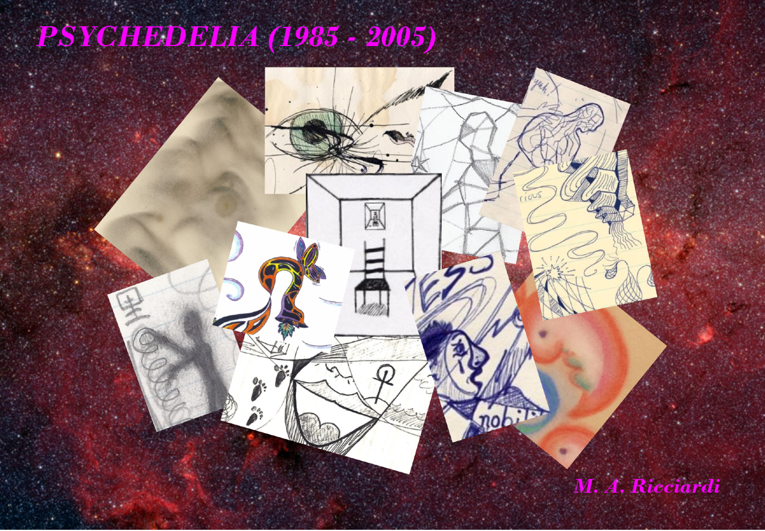

Psychedelia (1985 – 2005) by M. A. Ricciardi

Mescaline (‘red star’) – 1985 (Bridgewater, Mass.)
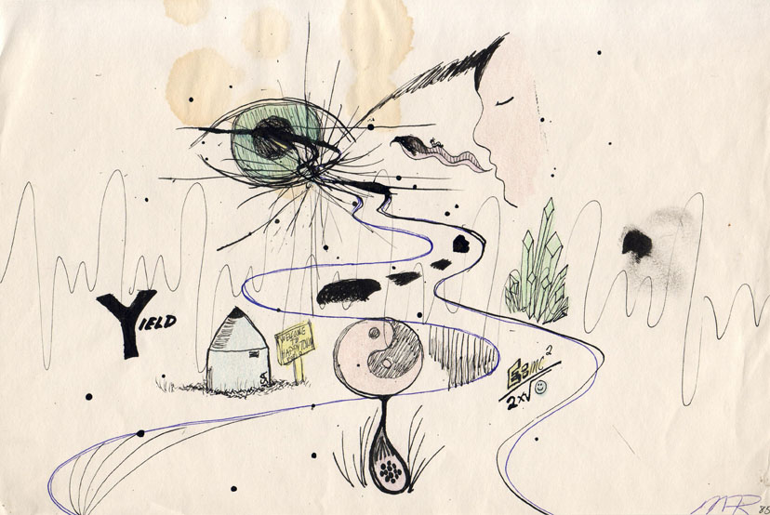
[close-up detail]
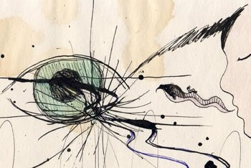
LSD (‘goony bird’ blotter) – 1986 (Plymouth, Massachusetts)
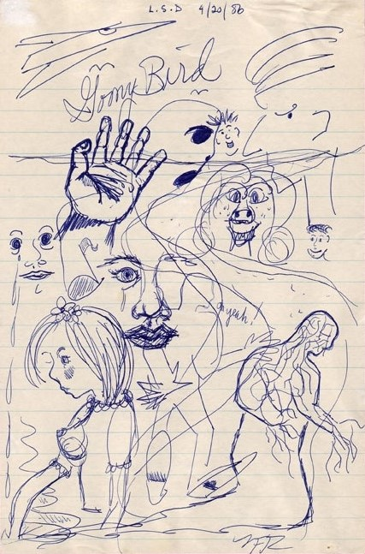
[close-up detail]
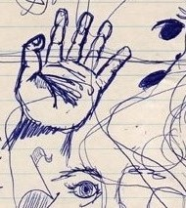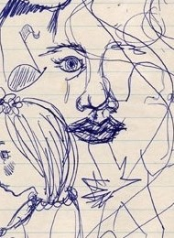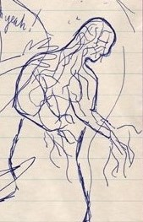

LSD (unknown brand) / Cannabis sativa (unknown strain) – 1986 (Plymouth, Mass.) – Note: quote by Theodore Roethke

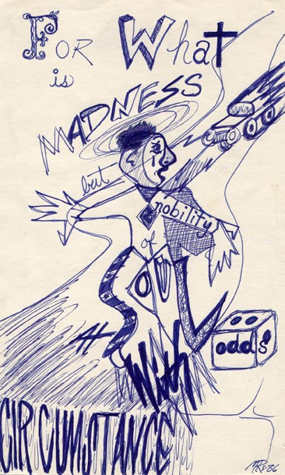
[close-up detail]

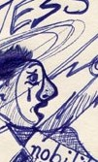 \
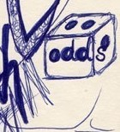

Cannabis sativa (‘Af-freak-an’ strain, grown from seed) – 1987 (Kingston, Mass.)
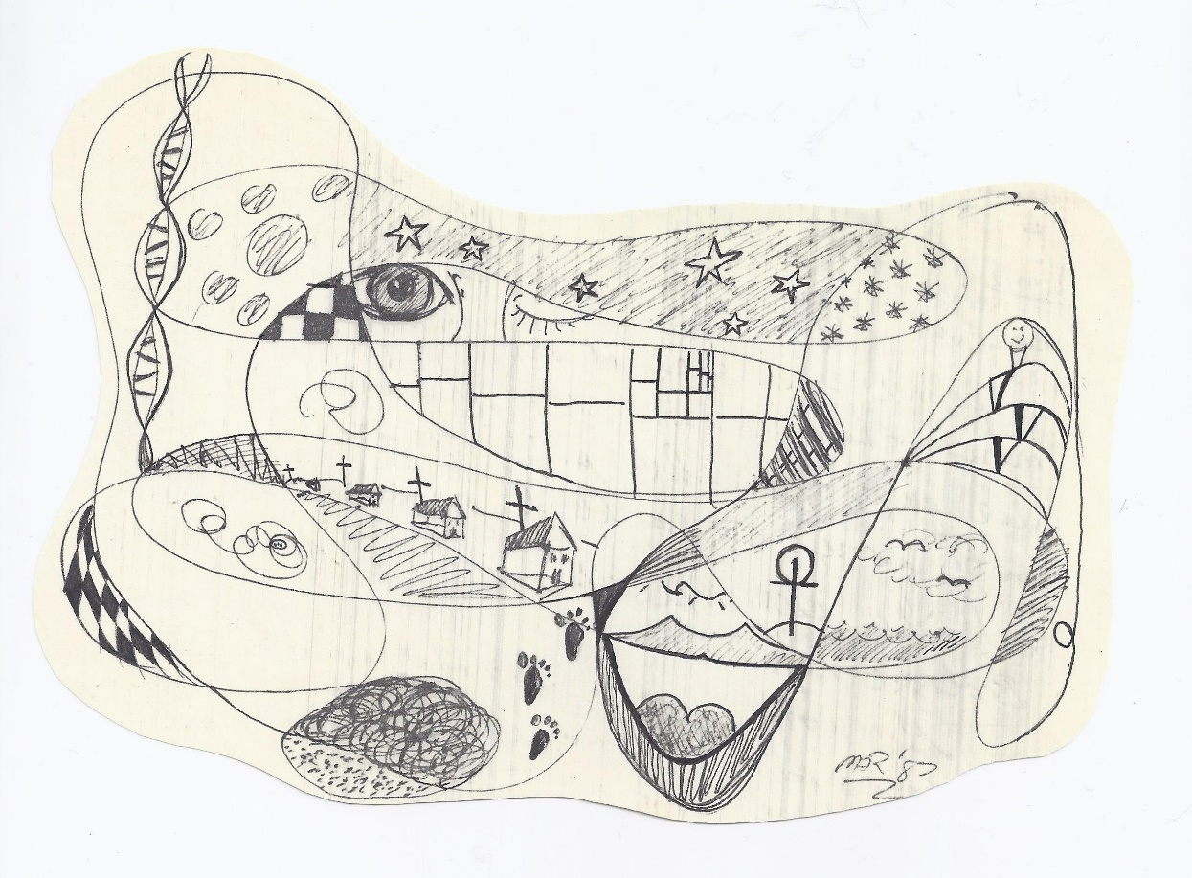
[close-up detail]
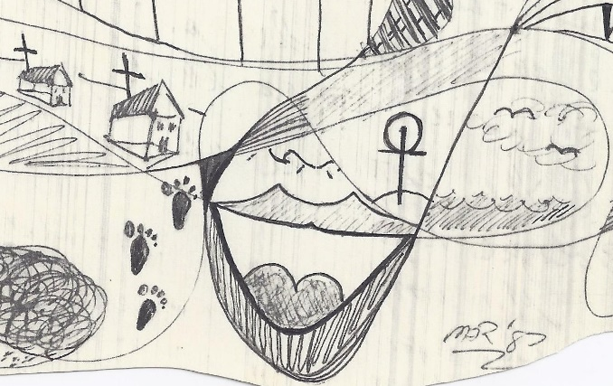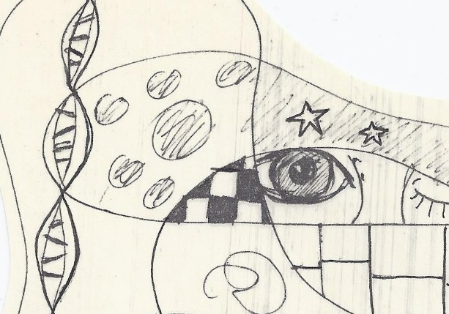

Unknown intoxicant (possibly Cannabis sativa) – 1987? (unknown location - Massachusetts) – Note: originally titled: ‘Delerium: 7 years old’ (a reference to my memory of a childhood illness)
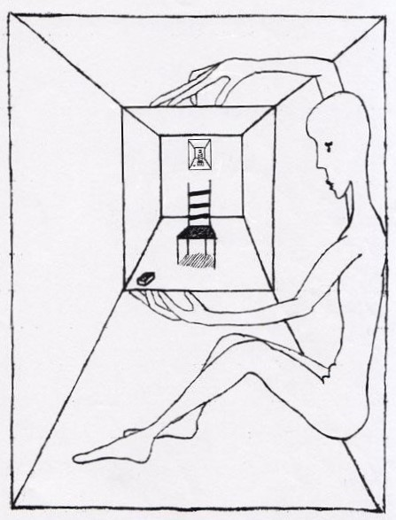
[close-up detail]
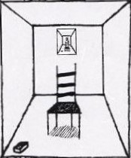
Hashish (Cannabis indica) – 1989 (Plymouth, Mass.) – Note: original title: ‘Fetal Dance’ (hand-drawn with pastel crayons)
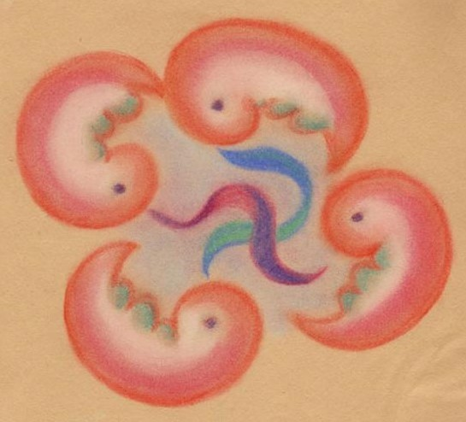
[close-up detail]
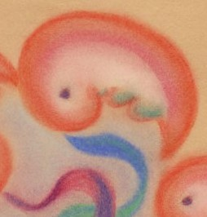
LSD (unknown ‘brand’ with Cannabis sativa) – 1989 (unknown location, probably Salem or Plymouth, Mass.) – Note: originally titled: ‘in sink’
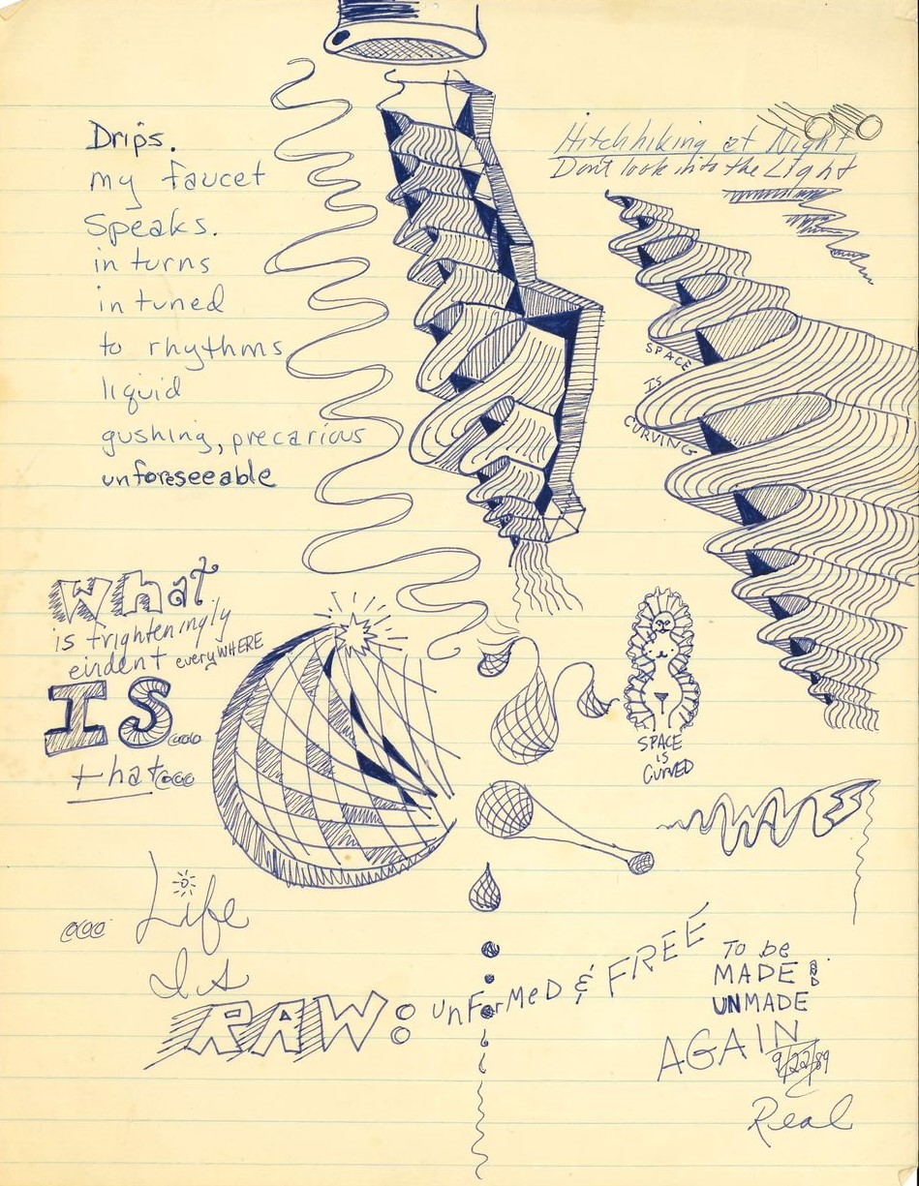
[close-up detail]
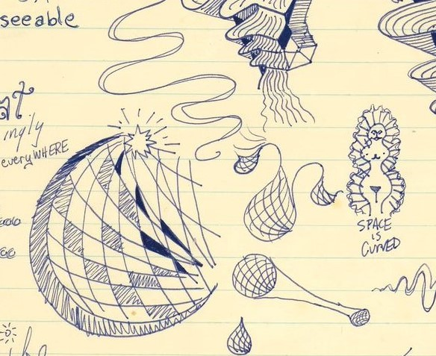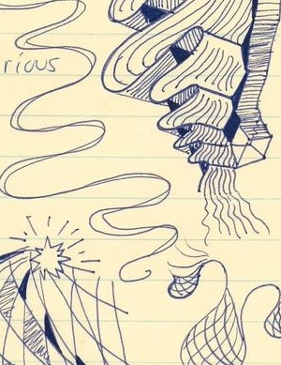
Cannabis (unknown strain) – 1992 or ’93 (Seattle, Washington) – Note: possible title: ‘There is a space within the space’ (taken from a hand-written note cropped out of image)
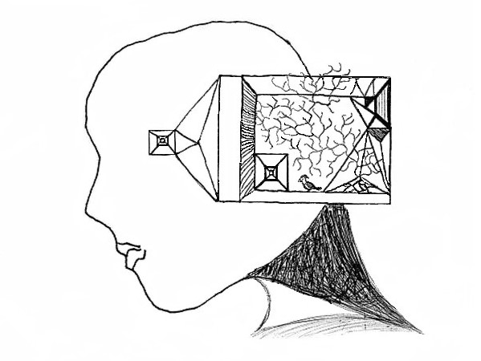
[close-up detail]
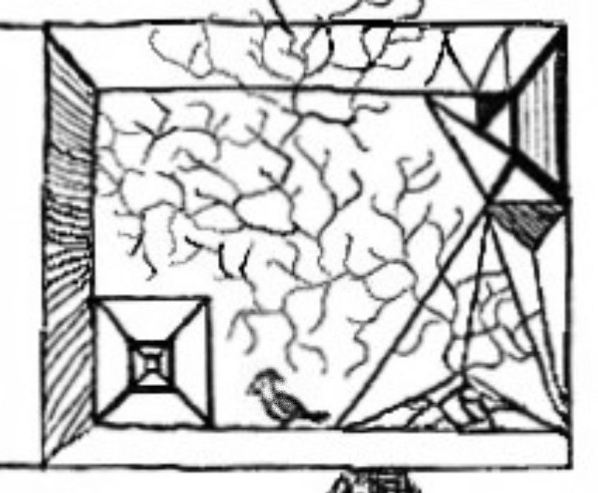
Mushrooms (Psilocybin cubensis) – 1995 (Seattle, Washington) – Note: a beeswax candle ‘fumage’ drawing (originally titled: ‘fossil’) with dripped wax spots and water shrinkage marks on right side.
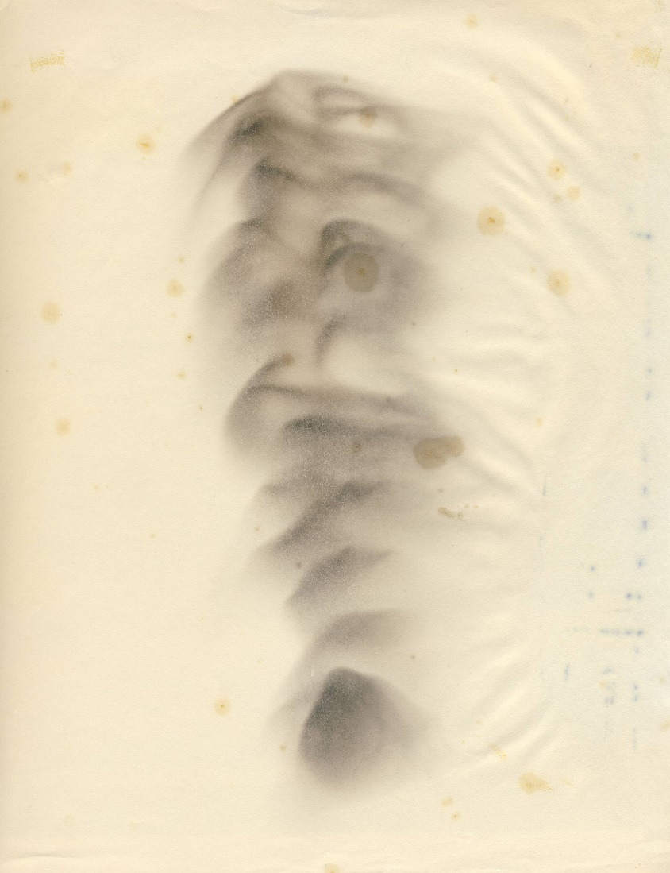
[close-up detail]
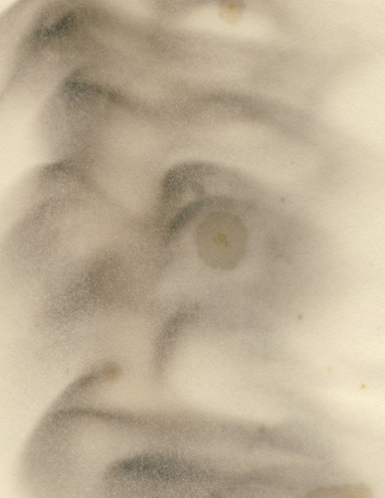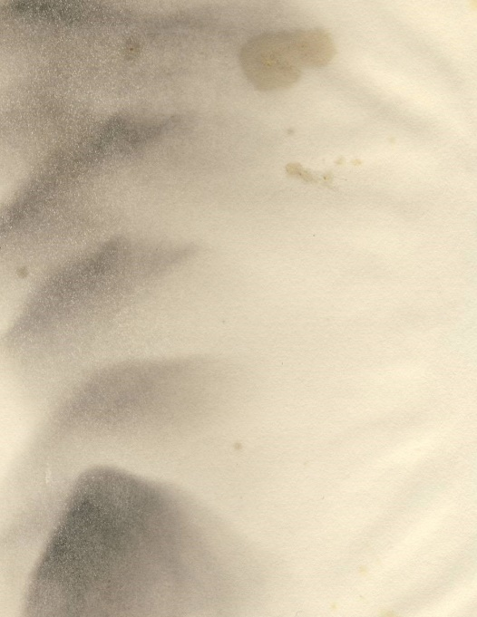
Cannabis sativa (unknown strain) – 1997 (Seattle, Washington) – self-titled.

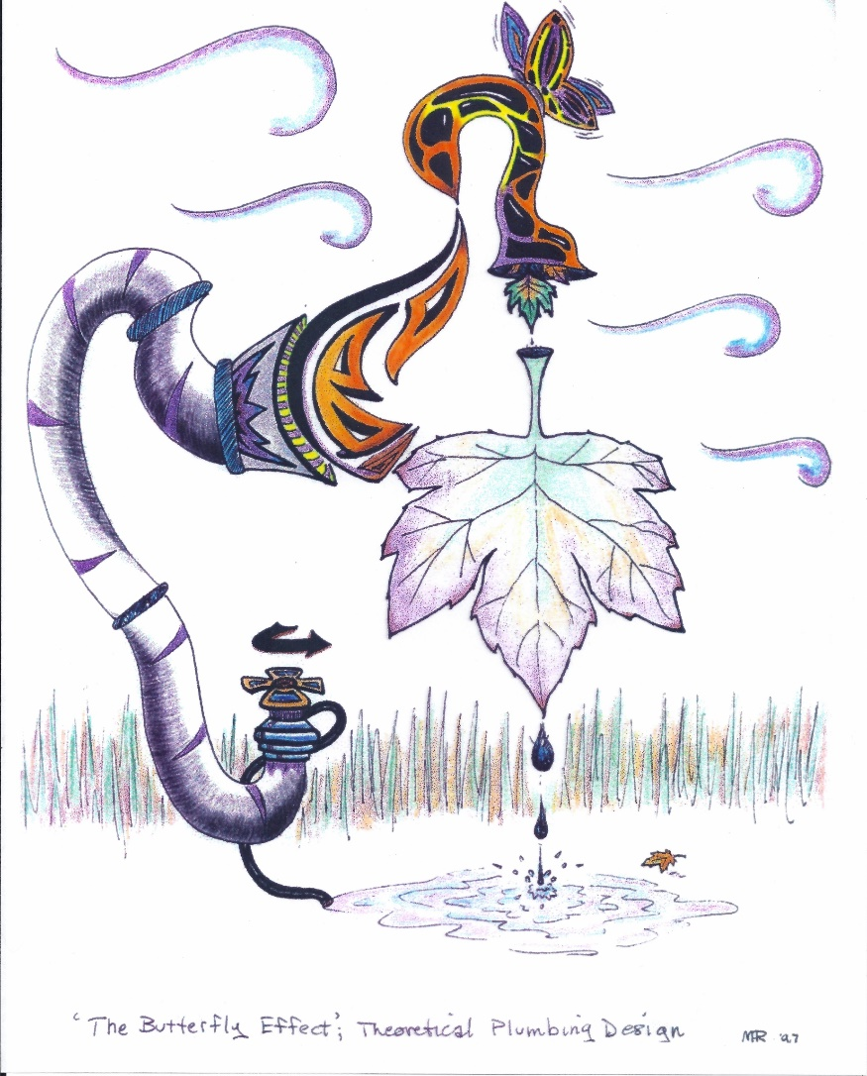
[close-up detail]
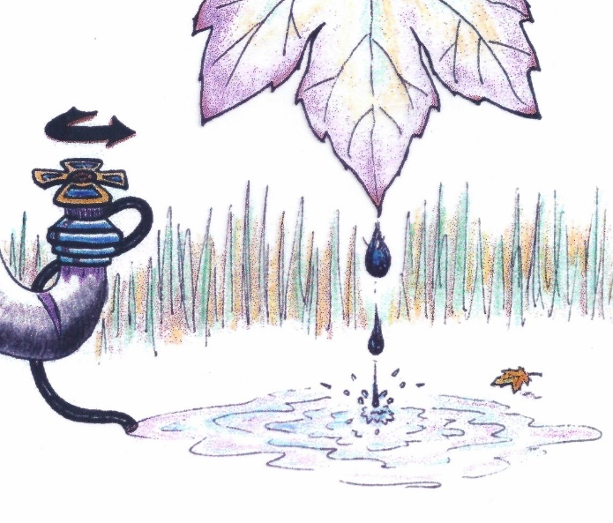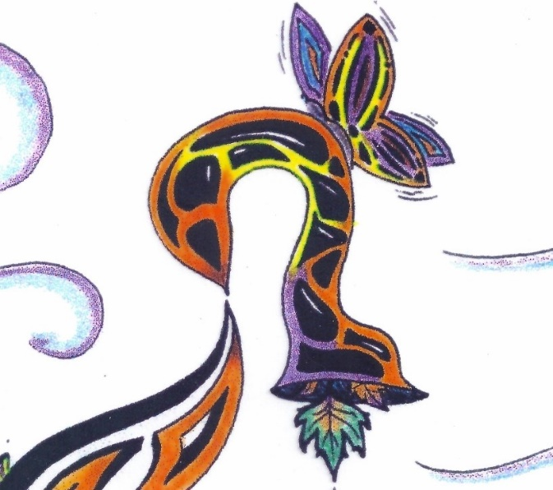

Cannabis sativa (unknown commercial hybrid ‘flower’) – 2001 (Seattle, Washington) – self-titled.
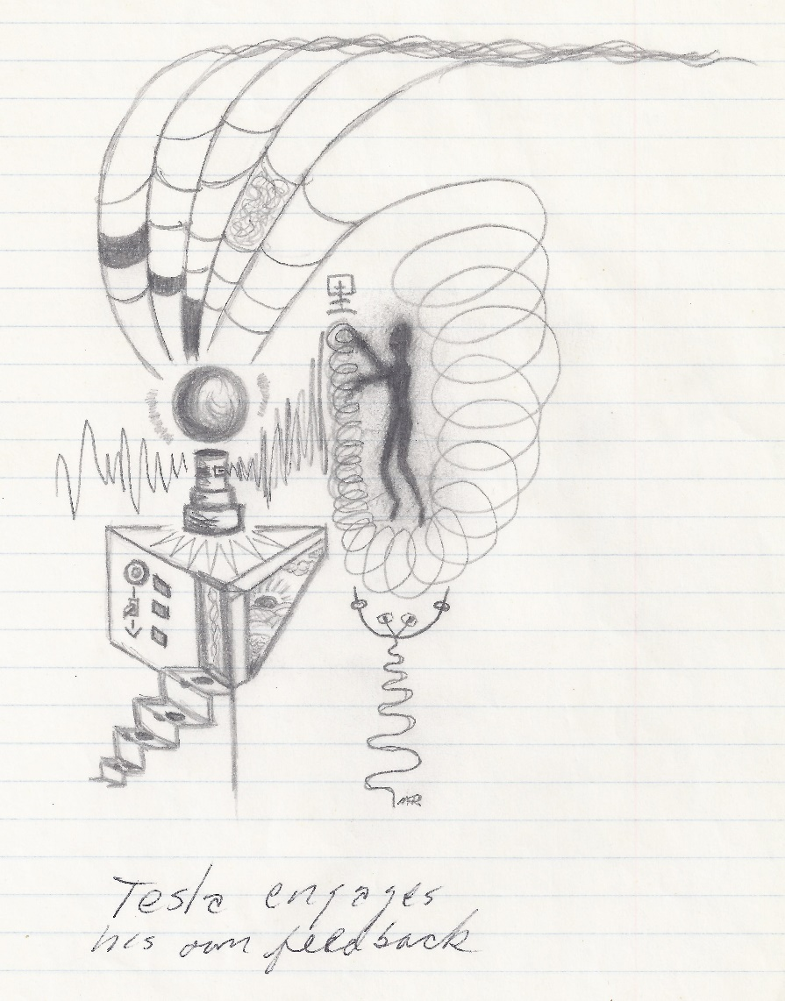
[close-up detail]
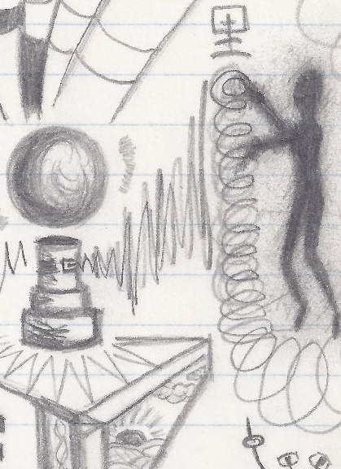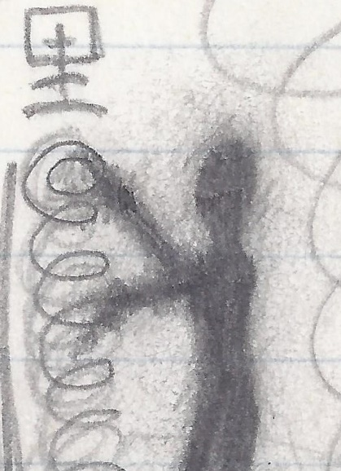
Cannabis sativa (unknown locally grown cultivar) – 2005 (Seattle, Washington) – Note: original title: ‘St Genome’.
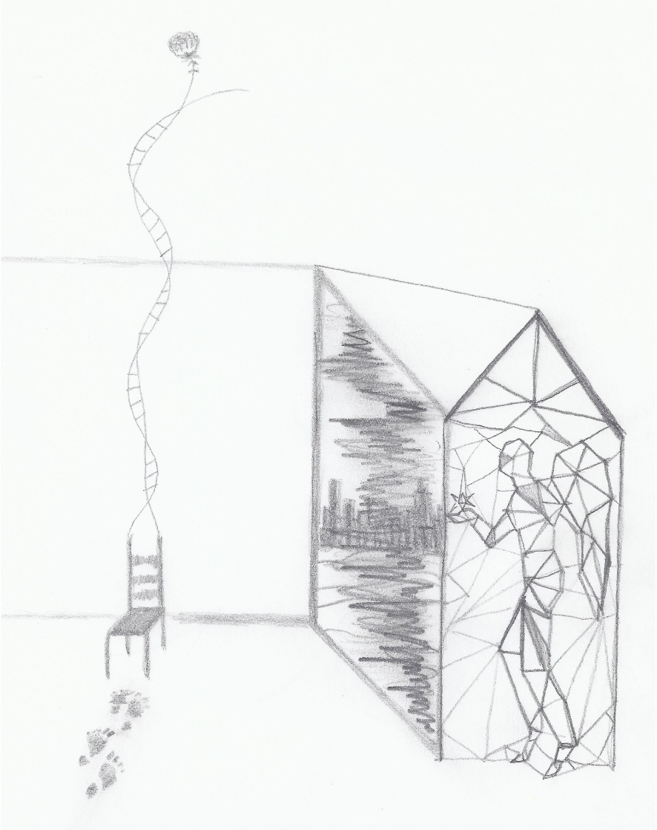
[close-up detail]
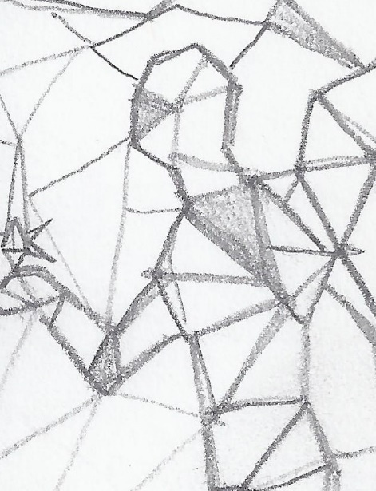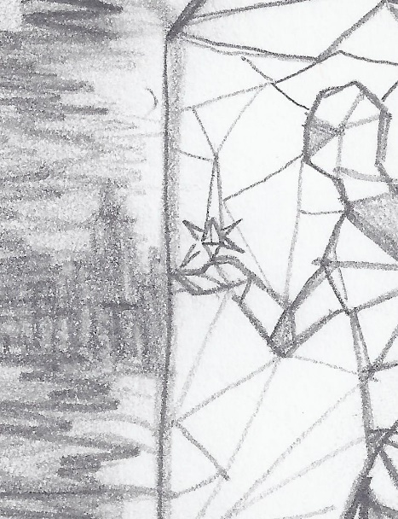
Artist’s End Notes:
All images are original to and hand-drawn by M. A. Ricciardi and are here reproduced with minimal to no digital alterations (some images were slightly cropped for space and some have slight contrast/exposure adjustments).
The psychedelic substance that was used/active at the time of creation is noted (when known or recollected) and the date/year for each work (if not noted on the works) are estimated as accurately as possible. Locations (states, cities/towns) are noted to the best of my memory but may be wrong in some (city/town) cases.
The publication of these images here is for personal documentation purposes and does not constitute a recommendation for use of psychedelics (nor is it a condemnation of psychedelics, although your opinion may differ).
Cover design by M. A. R. (background image: ‘Stars at the Galactic Center’, credit: Spitzer [space telescope] / Susan Stolovy – SSC Caltech et al / JPL-Caltech / NASA
M.A.R. (2024)

